1. 
2. In java, we have another tool for writing thread-safe code. This keyword solves the **visibility** problem not **the race condition.**
   1. It doesn’t prevent two threads modifying the same data at the same time but solves the visibility problem.
   2. It ensures that if one thread changes the data the other thread can see the change.
3. 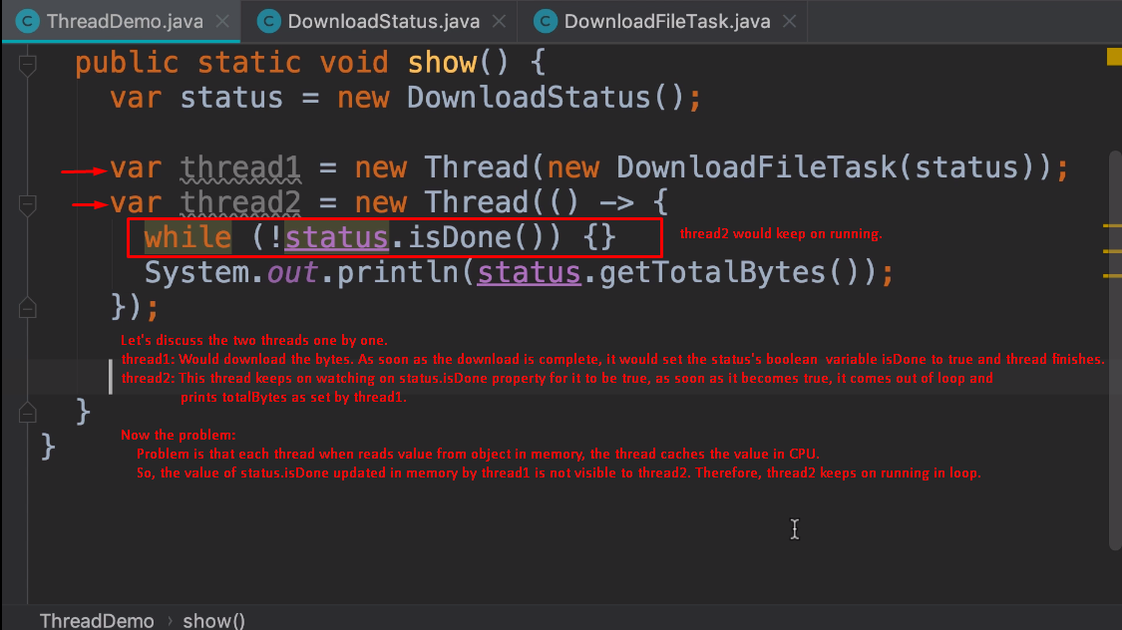
4. 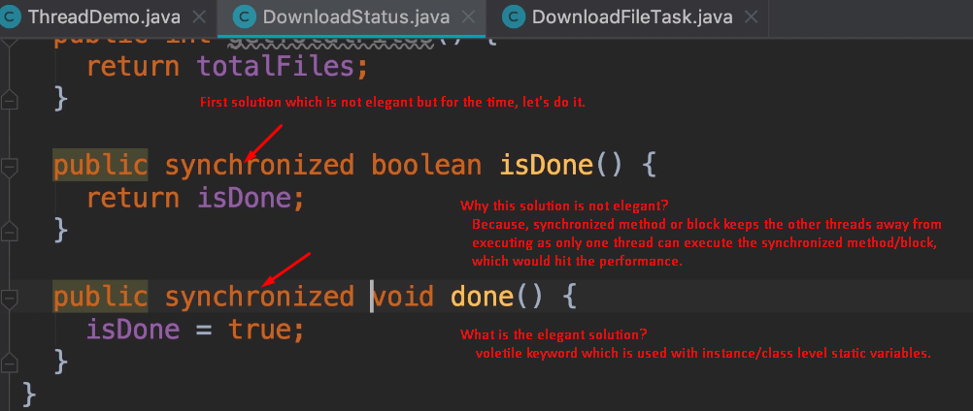
5. 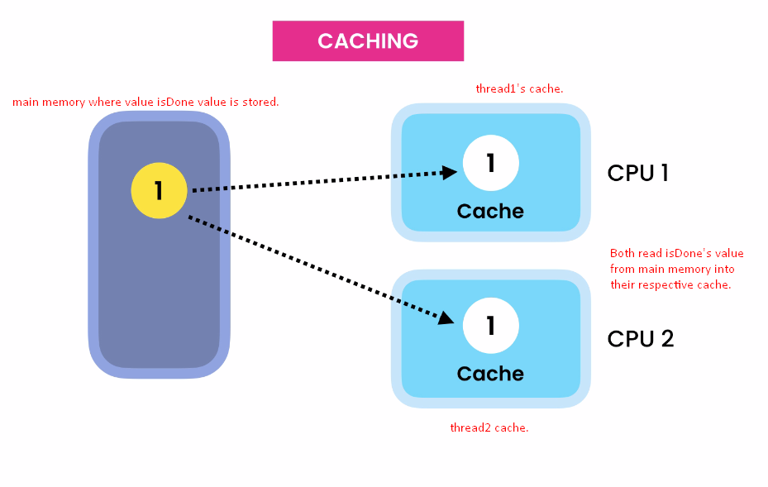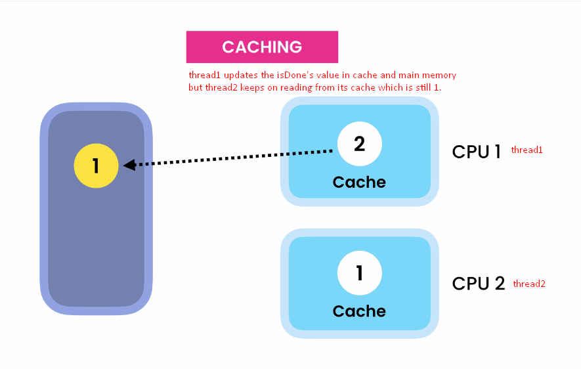
6. 